

**Name** : KAUTA MARVIN

**Registration Number** : S20B23/204

**Faculty/School** : SCIENCE AND TECHNOLOGY

**Course** : BACHOLERS OF SCIENCE IN COMPUTER SCIENCE

**Lecturer** : ***Mr simon lubambo***

**QUESTION ONE**

**I. DEFINE A STATEMENT OF WORK AND OUTLINE THE WORK PRODUCTS OF YOUR COURSE PROJECT.**

A statement of work a document that provides a description of a given project's requirements. It defines the scope of work being provided, project deliverables, timelines, work location, and payment terms and conditions.

Scope

The world for normal human being is far different than visually impaired, due to either lack of vision or no vision. The difficulties in their daily routines can be minimized with help of technological support which is usually aids that can be used for travelling. Computer vision a field of artificial intelligence provides the assistance for helping impaired. Information that peoples collect from their surroundings and the outside world is obtained through sight. visually impaired people suffer inconveniences in their daily and social life because of lack of sight. losing sight is one of the most unfortunate things that can happen to someone.

**PROBLEM**

* Unsafe Navigation through the environment.
* Difficulty in communicating with people in other locations.
* Difficulty in reading and writing for the visually impaired people

**TARGET GROUP**

Partially blind and completely blind individuals

**WORK PRODUCT**

A mobile-based app which has integrations with a variety of technologies like voice recognition software, image processing, and voice commands.(NLP). The application will have three core features namely

* **Facetime like module/feature**
* **Text to Speech Feature**
* **Speech to text feature**
* **Virtual and audio assistant**

**II. ELABORATE 5 POTENTIAL RISKS LIKELY TO THREATEN YOUR PROJECT AND HOW TO THEY CAN BE MITIGATED.**

**turn around time for service delivery**

This can be caused by unreliable internet speeds since some of these functions run online so internet being off means the person cannot use or gain help which affects the users who are solely dependent on this service.

**Mitigation**

Recommending specific types of phones that meet the standards and also giving promotions on internet bundles to reduce the costs, ensuring that the visually impaired always has an active hotspot of data connectivity.

**cyber attacks.**

Since some functionalities will run online, hackers may take this chance to break into devices for the visually impaired to gain access to their data or use it as a route to gain access to main severs since the visually impaired have no way of implementing security on there devices and cant detect incase of any attack on them. This data can be used to expose were these visually impaired people are and houses which may cause further damage.

**Mitigation**

Ensuring secure connections during real-time interaction between the agents and the visually impaired to prevent hackers from eves dropping or doing any malicious work

We can also ensure a good system security for both the company and the visually impaired.

**impersonation of virtual assistants**

virtual assistants are real-time human helpers who are there to help out the blind person just like a call center for the blind persons, impersonating to be a guide from a call center may be harmful because someone could use that as away of spying on someone for the wrong intensions which leads to harmful or negative effect.

**Mitigation.**

Encryption of these communication channels can be done to prevent anyone out of the company from contacting these personals, this will reduce fraud and impersonation since only the company can make calls to the specific people.

**physical robberies resulting from data picked during interactions**

**mitigation**

ensure a safe surrounding for the visually impaired that is secure enough to prevent robberies

**III. EXPLAIN THE FIVE STAGES OF YOUR PROJECT.**

1. **Requirement collection**

There are several ways of collecting the appropriate data which differ considerably in the context of money costs, time, and other resources at the disposal of the researcher

This also refers to the devices used to collect data, such as a paper questionnaire or computer-assisted interviewing system.

**sampling.**

In sampling, am aiming at dealing with selection and observing part of the universe to make inferences about the whole population. researcher/statistician may not deal with all. Here we do make a study of parts of the population and then we draw conclusions based on these parts selected for the whole population.

Sample frames will be used during this process of data collection. A sample frame is a list of distinct and distinguishable units of a given population, which is convenient for selecting units into a random sample.

To have more accurate values I will then use an area frame[1]. It is a collection of well-defined land units that are used to draw survey samples. Common land units composing an Area frame include states, provinces, counties, zip code areas, blocks, etc. Area frames of the Mukono district based on the surrounding of Uganda Christian University and its surrounding will be made useof by getting more information about the land boundaries from the Ministry of Lands, Housing & Urban Development.[2]

Therefore to a random sample of 100 people per frame. N represents several frames, we repeat N items as the procedure for selecting one person, each selection will be independent of any other.

**Qualitative and quantitative** methods of data collection are going to be used to collect data tools of data collection like:

**interviews.**

While using this collection tool for data, I will come up with different questions that will be used while interviewing the people in our community. Efficiency in interviewing is crucial because, of all the primary data collection methods, in-person interviewing can be the most expensive. Therefore to reduce the costs some of the interviews will be done physically and conducting them over the phone or through a webchat interface. Though sometimes an in-person interview can be worth the cost, as the interviewer can tailor follow-up questions based on responses in a real-time exchange.

Interviews also allow for open-ended questions. Compared to other primary data collection methods, such as surveys.

**Observation:**

Observation of students and other people around the community with disabilities mainly regarding the visually impaired during the times of navigation at a particular area where they are gathered will be used to assess their reactions and attitude towards the current system.

**Questionnaires and Online survey:**

Several online surveys and physical questionnaires are going to be used to collect data from both students, staff, and other community members about the current system and their requirements for the new system.

1. **System design**

This involves different stages from prototyping to implementation some design tools that we are to use are both software and hardware

**Design Tools**

1. Use Case Diagrams
2. Flow charts Diagrams
3. Sketch diagrams

**programming languages to be used.**

1. **Frontend and backend**
   1. flutter dart framework
   2. Django with python for ML and AI
2. **Database**
   1. Firebase and MySQL
3. **Other technologies**
   1. Deep learning
   2. Machine learning
   3. Algorithms
   4. Cloud services for storage and data processing

The languages, frameworks, and libraries to be used in the development of the visually impaired system using voice and image processing technologies include but are not limited to the following;

1. **API[3] and ALGORITHM –** these algorithms and API are embedded in mobile phones to do the object detection for us in real-time some of these algorithms include Most[4] important one-stage object detection algorithms
2. **YOLO (2016) (You Only Look Once)**
   1. As a real-time object detection system, YOLO object detection utilizes a single neural network. The latest release of Image AI v2.1.0 now supports training a custom YOLO model to detect any kind and number of objects
3. **SSD (2016) Single-shot detector**
   1. SSD is a popular one-stage detector that can predict multiple classes. The method detects objects in images using a single deep neural network by discretizing the output space of bounding boxes into a set of default boxes over different aspect ratios and scales per feature map location.
4. RetinaNet (2017) Region-based Convolutional Neural Networks
5. YOLOv3 (2018)
6. YOLOv4 (2020)
7. YOLOR (2021)
   1. YOLOR is a novel object detector introduced in 2021. The algorithm applies implicit and explicit knowledge to the model training at the same time. YOLOR can learn a general representation and complete multiple tasks through this general representation
8. **System implementations**

**This is also under system design given the fact that we are using agile development the product will keep on changing as we are building this product with the users them selves there fore more of these stages will keep interchanging with the previous step**

1. **Testing**

Product Testing is a process of measuring the properties or performance of products. Product testing is any process by means of which a researcher measures a product's performance, safety, quality, and compliance with established standards.

Here we test the product with different datasets and find out the possible failures and how we can mitigate them later.

**User acceptance trials**

The product is then rolled out to the users for trials and feedback. This feedback decides whether the product has passed the test to be sed by the public or it needs refining to meet the feedback standards

**IV. IS YOUR PROJECT OBJECTIVE DRIVEN OR PRODUCT DRIVEN, ELABORATE ON THE DIFFERENCE.**

My project is a an objective driven with a product ant the end of it all.

Accomplishing certain goals or milestones in the product development means that the final product will have less errors in the making since each goal is being achived and reviwed.

**Difference between objective driven and product driven**

In object driven projects the main objective of the final outcome is considered. But doesn’t take much effort to build the finalized fully functioning expected version at the initial iteration. Incremental approach is considered until the final objective is accomplished.  
**disadvantages**

1. Not matching the finished version with expectations
2. over going with the budgeted price
3. delays in project finish time are some of them.

**product driven**

Here the actual problem is identified and only have to develop a previously determined or designed product. That means only the implementation part of the project is remaining.

all the functions of the project are focused on the product its design, features, capabilities, and its subsequent designs are done here. Product driven means we focus on the user product. The final goal is a product

QUESTION TWO

1. I. EXPLAIN THE AGILE METHODS

The Agile methods are ways to manage a project by breaking it up into several phases. It involves constant collaboration with stakeholders and continuous improvement at every stage. Once the work begins, teams cycle through a process of planning, executing, and evaluating.

The most popular and common examples are

* Scrum
* extreme Programming (XP),
* Feature Driven Development (FDD),
* Dynamic Systems Development Method (DSDM),
* Adaptive Software Development (ASD),
* Crystal
* Lean Software Development (LSD)

II. DRAW A PRODUCT BREAK DOWN STRUCTURE FOR YOUR PROJECT

Mobile agro mapping app

Systems Designs

Software

Documentation

Login page

Sketches

User interface module

Project plan

Registration page

HELPER PAGE

Flowchart

Visually impaired

page

Requiements document

Erd database model

User manual

UI/UX Design prototype

Backend module

Authentication

Virtual assistant

Real time database

Database module

NLP data processing

prototyping

Database module

DRAW THE PRODUCT FLOW DIAGRAM AND THE DERIVED ACTIVITY NETWORK

**Activity flow charts**

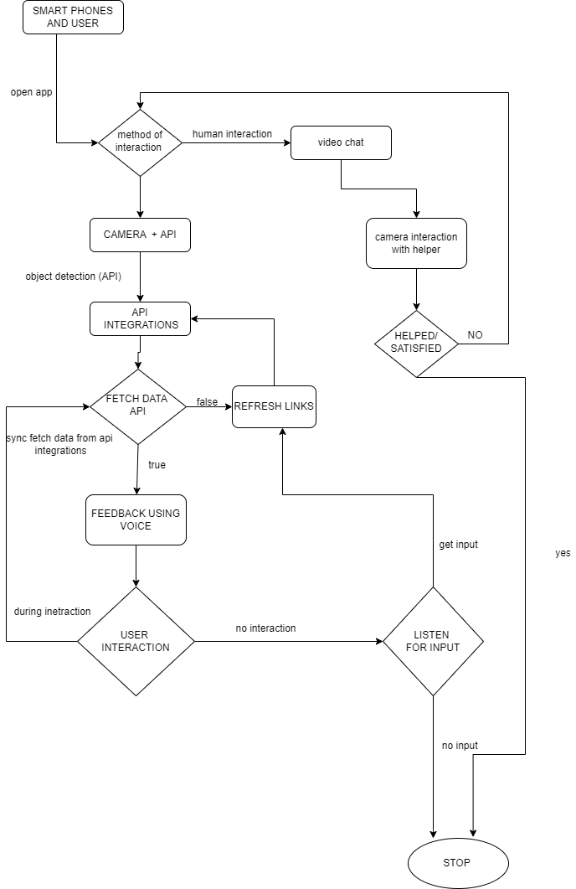

**Individual processs flow diagrams**

**APPLICATION DASHBOARD**

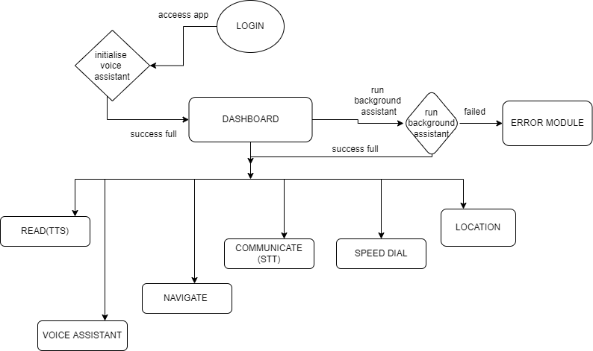

**ON SELECTION OF: READ (TEXT TO SPEECH )**

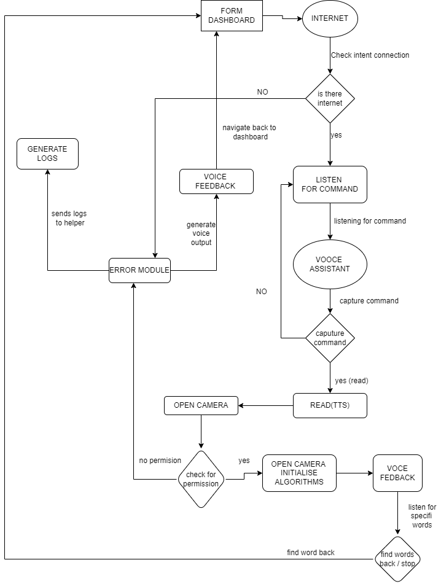

**ON SELECTION OF: EMERGENCY (SPEED DIAL)**

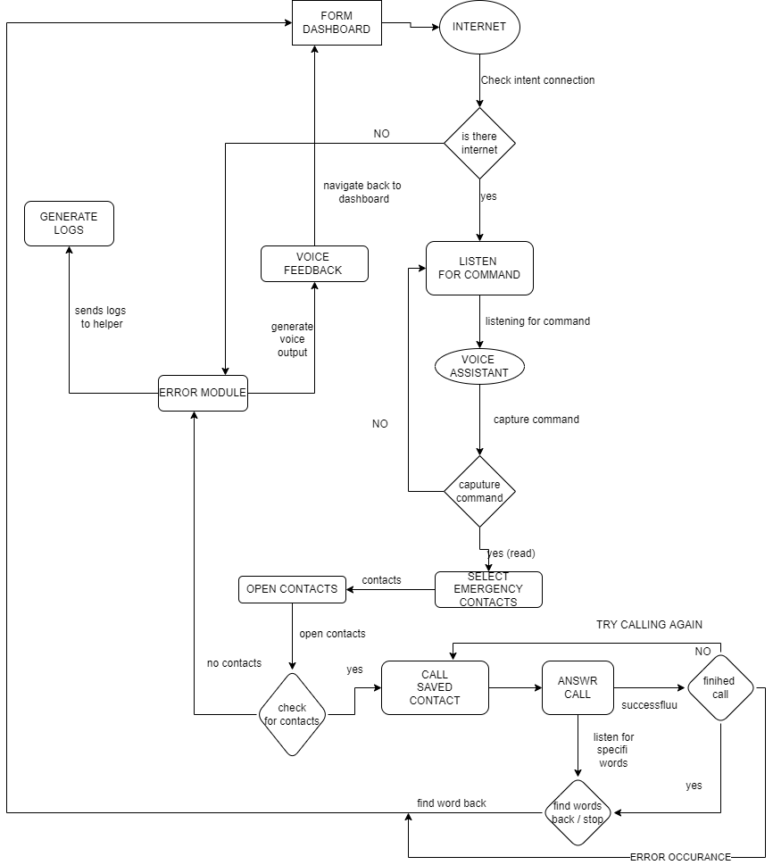

**ON SELECTION OF: NAVIGATION**

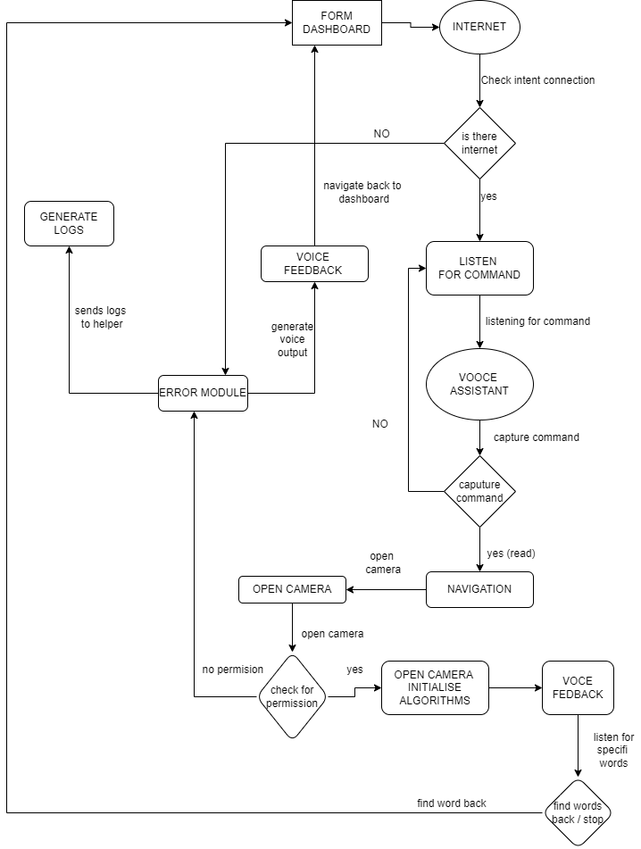

**ON SELECTION OF: COMMUNICATION**

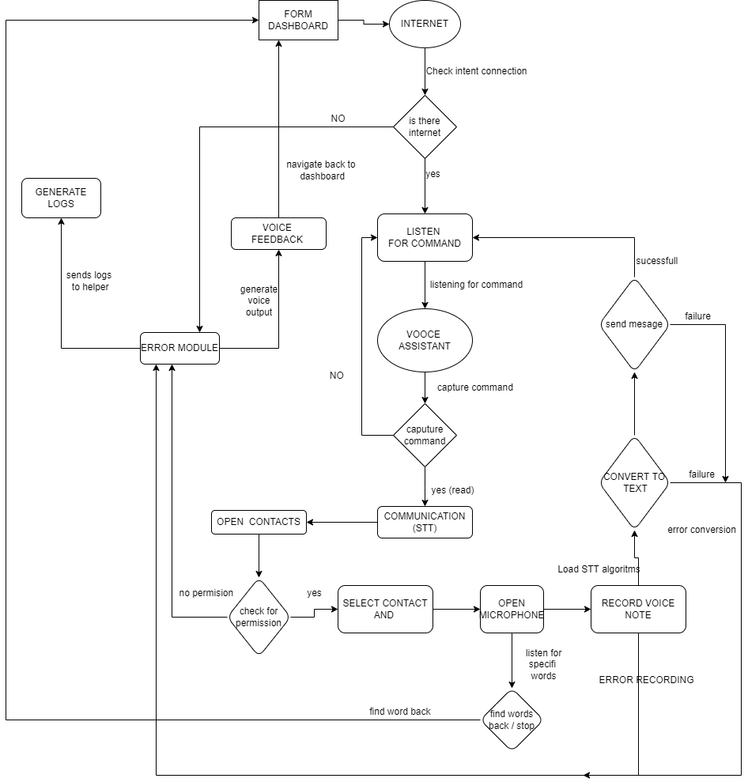

**The helper module**

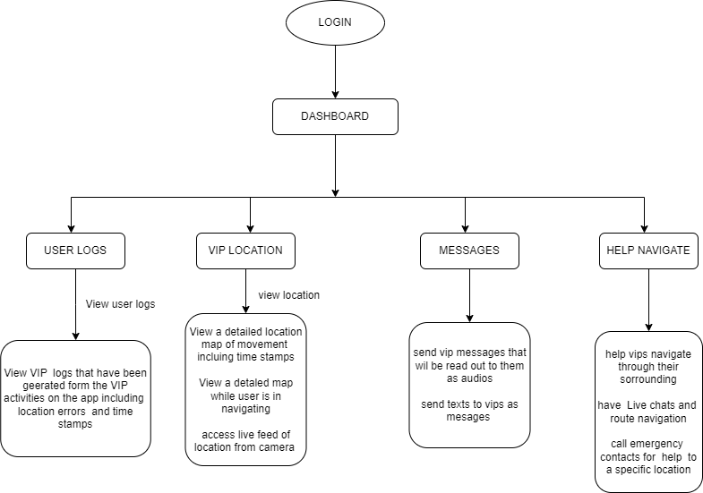

**QUESTION THREE**

**DEFINE THE DIFFERENT TYPES OF CONTRACTS[5] IN SOFTWARE PROJECTS**

**Fixed Price Contract (FP)**

Choosing this type requires fully detailed specifications, project scope statements, and checklists from the seller side. Both sides agree on a fixed price. It means that when the project is delayed as well as there are cost overruns, the seller will absorb all the extra expenses. With this option, the buyer is in the least risk category. Thus, while it is useful for controlling the cost, the downside for FP is that deviating from the defined scope can be expensive. Therefore, it is better to opt for this type when the scope of work is already clearly defined and the set requirements are well understood.

This type is also divided into several subtypes:

* Firm Fixed Price (FFP) is the most common one. The price is set from the outset and cannot change unless there is a change in scope;
* Fixed Price Incentive Fee (FPIF) model is usually chosen to offer the seller a performance-based incentive. It can be dependent upon certain project metrics, including development cost, time, and performance;
* Fixed Price Award Fee (FPAF) is used when the expectations from the seller can be exceeded. If the product is finished earlier than expected, an extra payment will be received;
* Fixed Price Economic Price Adjustment (FPEPA) option gives you an opportunity to readjust the fixed price according to the fluctuations in the market. Usually, it is chosen in the case when a project is going to last for multiple years.

**Cost Reimbursable Contract (CR)**

This type is used when the requirements are uncertain from one side and the development process is not clear from the other. It is used for new research and development and requires immense innovation without a guarantee of predicted outcome. The key idea of this contract is that the seller provides work for a fixed time period and then increases the bill to get profit after finishing the product. The amount of the raise in this case is unknown to the other party, because it is not discussed prior to the agreement.

There are subtypes that you can choose from if you decide to go for this option:

* Cost Plus Percentage of Cost (CPPC) arrangement mainly benefits the seller. Upon completion of the software, they get the total cost they incurred during the software development as well as a defined percentage of the total cost;
* Cost Plus Fixed Fee (CPFF) ensures that, besides the cost incurred on the product, the seller gets an additional fee as well. The profit is set at the beginning of the project;
* Cost Plus Incentive Fee (CPIF) option contains a performance-based fee that is paid on top of the actual expenses;
* Cost Plus Award Fee (CPAF) type provides an award on top of the costs incurred.

**Time and Material Contract (T&M)**

This is the second popular option after FP, and it is a hybrid of both FP and CR. One of the parties agrees to pay the other the time and materials that are used for the project within a reasonable limit. It can be cost reimbursable when the customer agrees to pay the cost for all the genuine and legitimate expenses. Or, it can be more like a FP type when the customer sets the limit.

In this case, the vendor is selected based on the capabilities and experience, having the required manpower and materials. The cost for supplies is negotiated and is paid according to the quantity of the resources consumed or purchased. The contract is pretty simple and convenient for both parties, and it is possible to establish a not-to-exceed price to avoid massive cost overruns.

**Unit Price Contract**

This type is less popular than the other three options and is also known as an hourly rate contract. It combines the elements of the FP and CR models, just like T&M. However, this option differs on setting the price per item or unit not per hour rate along with the receipts for all the resources used in the overall process.

If you choose the unit price contract, it will ensure that the party that is engaged in the development process is paid a specified hourly rate for every hour its members spent on the overall software development process. This is the main advantage of this type. That is why it is usually used by freelance workers.

1. <https://ec.europa.eu/eurostat/cros/content/area-frame_en>
2. <https://mlhud.go.ug/>
3. <https://viso.ai/deep-learning/object-detection/>
4. <https://viso.ai/deep-learning/object-detection/>
5. <https://xbsoftware.com/blog/types-of-contract-in-software-project-management/>